Week 2 Report: Steganography Project

The second week of the project was primarily focused on user interface design, feature development, and in-depth research on image properties related to steganography. This phase was essential to establish the basic structure of the front-end and build the core functional elements that would support a smooth and intuitive embedding experience for the user. During this week, I designed and developed the first interface page of the application, which includes a simple yet effective layout with a text input box for entering the secret message and a file upload feature for selecting the carrier image. As previously suggested, I integrated a toggle option that allows the user to choose between embedding with or without encryption. Although the encryption functionality itself is not yet implemented, its presence in the interface ensures that the design is modular and ready for future extensions, particularly in preparation for the detection software and security-focused upgrades.

Another key feature added this week was the dynamic display of image properties upon image selection. The application now reveals essential details such as the file size, resolution, file type, and colour mode (e.g. RGB, RGBA, L, P). This was included not only to assist users in estimating how much message data the image can carry, but also to offer an educational dimension allowing users to better understand how different image types and modes affect steganographic capacity. These insights are particularly valuable given that color modes and formats like BMP, PNG, and JPEG differ significantly in terms of compression and suitability for pixel-level manipulation.

In addition to development tasks, I also focused heavily on research, particularly exploring alternatives to the traditional LSB (Least Significant Bit) embedding method. Previously, I assumed that LSB was the only practical technique used in steganography. However, based on your recommendation, I investigated alternative methods and selected a promising approach that combines Discrete Cosine Transform (DCT) with encryption. This method operates in the frequency domain rather than the spatial domain and offers better robustness and security, especially in scenarios where images are compressed or undergo transformations. Choosing DCT + encryption as a potential future module allows the project to scale beyond basic hiding techniques and align with real-world applications where security and resistance to detection are critical.
Design Specification of Page 1 : Steganography Embedding Interface

Design Goals
- Provide a simple, intuitive interface for embedding text into images.
- Support file upload and message input.
- Offer an option to embed with or without encryption (future-ready design).
- Display image metadata (size, resolution, mode, etc.) to assist users.
- Keep the layout clean, responsive, and suitable for future features.

Feature List with Descriptions
1. Typing Animation Header
The first feature is a Typing Animation Header, which uses the Typed.js library to display the animated text "Steganography - Hide Your Message" in the header area. This small enhancement brings interactivity and improves the visual experience for users visiting the page.

2. Navigation to Extraction Page
To support seamless navigation, a Navigation Button is provided that redirects users to the extraction page. This is implemented using a Bootstrap-styled link button labelled “Go to Extract Page,” making it easy to switch between embedding and extraction workflows.

3. Input Method Toggle (Text / File)
The interface offers an Input Method Toggle that allows users to choose between typing a secret message or uploading it as a .txt file. This is implemented using two radio buttons “Enter Text” and “Upload File” and dynamically displays the appropriate input field based on the user’s selection.

4. Encryption Toggle
An Encryption Toggle is also included as a future-ready feature. Using a switch component, the user can select between embedding with or without encryption. This toggle updates a hidden field (encryptionState) to reflect the user's choice as 1 (enabled) or 0 (disabled), making it ready for integration with server-side encryption logic.
5. Secret Message Input
When “Enter Text” is selected, a Secret Message Input field appears. This field is a standard <textarea> that allows users to type the message they want to embed within the image.

6. Message File Upload
If the user chooses the file-based input option, a Message File Upload field becomes visible. This file input accepts .txt files and allows the user to submit a message stored in a text document.

7. Image Upload for Embedding
A Carrier Image Upload field is a mandatory component where users select an image to embed their message into. It accepts all common image formats and triggers further actions like image preview and property analysis.

8. Image Preview Display
After selecting an image, a Live Image Preview is displayed using an <img> tag. This allows the user to visually confirm the image before the embedding process begins.

9. Image Properties Display
Alongside the image preview, an Image Properties Display section dynamically shows file-related metadata. This includes the image name, type, size in kilobytes, resolution, and a list of common color modes like RGB, RGBA, L, and CMYK. While the current script does not auto-detect the exact mode, it educates the user about the possibilities and helps them choose the appropriate image.

10. Embed Button
To begin the embedding process, an Embed Button is provided. It is a styled submit button labeled "Embed Message" and sends the form data secret message and image to the /embed route on the server.

11. JavaScript Utilities
Lastly, the interface is supported by several JavaScript Utilities. The previewImage() function handles the preview and metadata extraction of the selected image. toggleLabel() updates the encryption toggle label and color based on the user's selection. toggleInputOption() manages the display of either the text input or file input. All initialization logic, including setting the default state, runs inside a DOMContentLoaded event listener to ensure proper functionality after the page loads.

Reason Behind to Implement Specific Features

Encryption Toggle Button
The inclusion of the encryption toggle button in the interface is a deliberate design choice rather than simply enforcing encryption by default. While it is technically possible to apply an encryption algorithm automatically before embedding, providing a manual toggle offers both functional flexibility and educational value.
From a development perspective, this toggle allows for future experimentation with a detection system, where the application can attempt to distinguish between encrypted and non-encrypted embedded messages. Having both types of data available in the system helps simulate real-world steganalysis scenarios. This feature is therefore essential for research-oriented development.
From a user’s perspective especially students, educators, and researchers the toggle makes the concept of encryption in steganography more visible and understandable. It lets users compare outcomes and behavior of encrypted versus plain-text embedding, offering insight into how encryption can enhance message security and reduce detectability. In essence, the encryption toggle bridges usability and learning, making the system more versatile for both practical and instructional use cases.

Image Properties Display
The image properties display was added to give users better insight into the technical characteristics of the selected carrier image, which directly impacts the embedding process. Steganography is not just about hiding data it’s about understanding how and where to hide that data in a digital medium. Hence, showing image details like file size, resolution, format, and especially colour mode, serves an important role.
This feature helps users estimate how much message content can safely be embedded into the image without corruption or noticeable distortion. For example, a high-resolution RGB image can usually store more data compared to a grayscale or indexed color image of the same dimensions. The inclusion of the colour mode (e.g. RGB, RGBA, L, P, CMYK) is particularly significant. It allows users to recognize the type of image they are working with, which is critical because different modes imply different bit depths, channel counts, and embedding capacities. Moreover, since this project is built with educational value in mind, this display also serves as a learning tool. It encourages users to explore how image types affect steganography, promoting a deeper understanding of digital media formats and their roles in secure data hiding. By visually providing this information, the system supports both technical decision-making and foundational learning in the domain of image-based steganography.

Screen shots of the Design
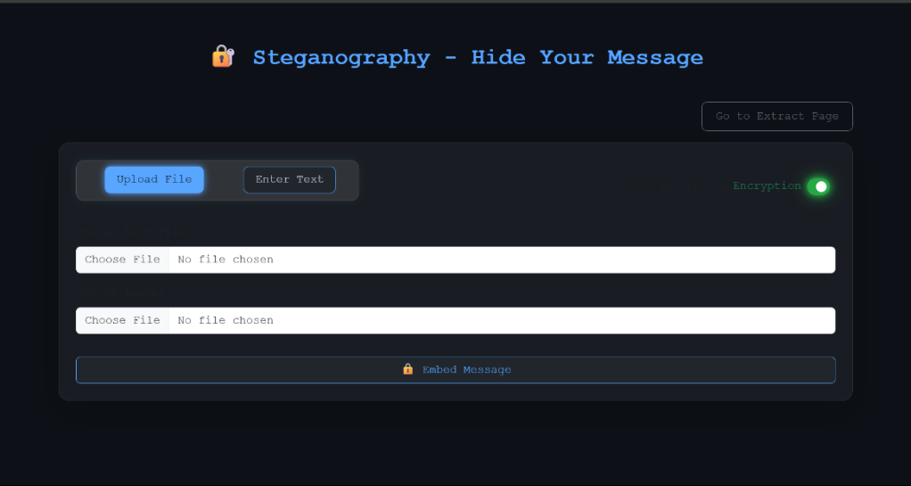

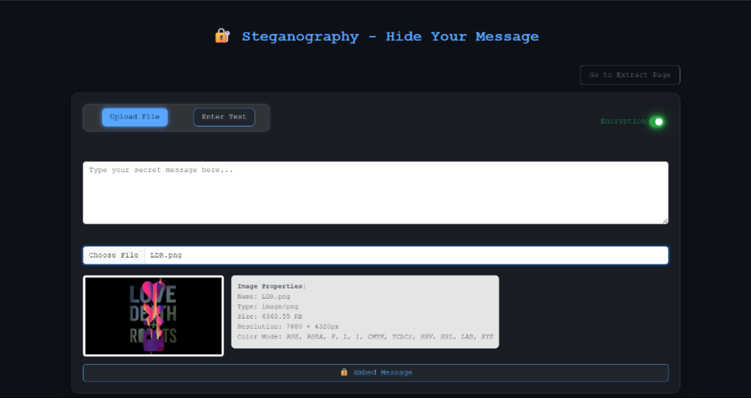

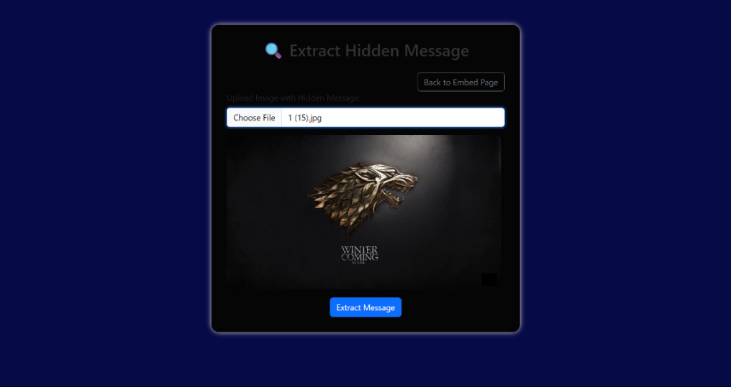

*NOTE :
Design of the 2nd page is still in the unfinished.
The Colour Mode under Image properties feature in 1st page, is still under developing phase. For now, I just apply a plain text

Challenges Faced During Week 2 : Design and Development

1. Implementing Colour Mode Detection in Image Properties
One of the significant challenges I encountered this week was implementing accurate colour mode detection as part of the image properties display. During my initial research into image formats and steganography, I realized that colour mode plays a crucial role in determining how and where a message can be embedded. For example, RGB images have more embedding capacity compared to grayscale or indexed colour formats. Therefore, I decided that this feature should be included in the interface to improve both usability and educational clarity.
Initially, I attempted to extract the colour mode using JavaScript on the client side. However, I soon realized that JavaScript's ability to analyse and differentiate between colour modes is very limited. The preview system would often default to displaying only "RGB", and even after some code refinements, it inconsistently showed RGBA. This made the feature unreliable and inaccurate, especially for more complex image formats.
To improve this, I explored advanced JavaScript-based algorithms with the help of ChatGPT, but the suggested logic was quite complex and difficult to implement accurately within the browser environment. Despite those efforts, the detection was still not satisfying in terms of reliability.
Eventually, I searched for alternative approaches and discovered that the Python Pillow (PIL) library offers robust support for detecting and working with image colour modes. This library can easily read the mode attribute (e.g., "RGB", "CMYK", "P", "L") from any image file with high accuracy. As a result, I have now shifted this part of the functionality to be handled server-side using Pillow, and I am currently working on integrating Pillow into the backend to provide accurate colour mode data as part of the image property panel.

2. Separating HTML, CSS, and JavaScript Files for Maintainability
Another challenge I faced was related to the organization of code files. Initially, since this was a small project, I assumed that a single HTML file with embedded CSS and JavaScript would be sufficient. However, as the design grew more complex and more features were added, it became increasingly difficult to manage and modify the code.
To resolve this, I decided to separate the code into three distinct files HTML, CSS, and JS. This greatly improved the maintainability and scalability of the project. With each file handling its own responsibilities, I could now debug and update the project much more efficiently.
Additionally, I encountered another minor but important issue while linking the external CSS and JS files. I initially used direct path references, but later realized that this approach could cause problems, especially when sharing or deploying the project. Based on Flask’s best practices, I replaced all static file paths with url_for() statements. This ensures that Flask dynamically handles file referencing, making the app more portable and less error-prone during deployment or sharing.

Reflection on the Prototype Implementation

In this prototype, I implemented the Least Significant Bit (LSB) technique as the core algorithm for image-based steganography. The concept of LSB embedding was both interesting and relatively straightforward to implement. However, the overall experience was not entirely satisfying due to certain challenges and limitations particularly during the extraction phase.
While embedding the message into the image was smooth and fast, the extraction process proved to be more intricate. It required careful bit handling and precise detection of the end marker. Despite these efforts, the output sometimes turned out to be unexpected or incorrect, especially in cases where the image properties were altered or inconsistencies occurred in the bitstream. Additionally, I identified a few drawbacks of this technique, which will be discussed in detail later in this report.
That said, as this was a prototype, the primary objective was to gain a deeper understanding of the internal workings and significance of steganographic techniques including their strengths, vulnerabilities, and potential areas for improvement.
Through this experience, I learned that although LSB is an excellent entry point for understanding image steganography, but it may not be the most reliable approach for real-world or production-level applications. This project reinforced the importance of selecting techniques not just for their simplicity, but also for their robustness, resistance to compression, and overall security.
Looking ahead, I plan more advanced and hybrid steganographic methods beyond basic LSB such as DCT-based techniques (Discrete Cosine Transform) to build systems that are more secure, reliable, and resilient.

About the Prototype Algorithm and Working

While developing the algorithm, I faced challenges in accurate bit manipulation, especially ensuring the image appearance remained unchanged after embedding. During testing, the main issues were related to the extraction phase—it was slower and sometimes produced incorrect outputs due to bit misalignment or format issues. Handling the end marker correctly and ensuring compatibility with different image modes also required careful debugging.
Despite these challenges, the project helped me understand the strengths and limitations of LSB-based steganography, particularly its simplicity and its vulnerability to compression or image modifications.
Demo1.py [Embedding Code]
from PIL import Image

def message_to_binary(message):
return ''.join([format(ord(char), '08b') for char in message])

def hide_message_lsb(image_path, message, output_path='stego_image.png'):
img = Image.open(image_path).convert('RGB')
pixels = img.load()

width, height = img.size
binary_message = message_to_binary(message) + '1111111111111110' #16-bit end marker
data_index = 0
msg_len = len(binary_message)

for y in range(height):
for x in range(width):
if data_index >= msg_len:
break
r, g, b = pixels[x, y]
if data_index < msg_len:
r = (r & ~1) | int(binary_message[data_index])
data_index += 1
if data_index < msg_len:
g = (g & ~1) | int(binary_message[data_index])
data_index += 1
if data_index < msg_len:
b = (b & ~1) | int(binary_message[data_index])
data_index += 1
pixels[x, y] = (r, g, b)
if data_index >= msg_len:
break

img.save(output_path)
print(f"Message hidden successfully in '{output_path}'")

message = input("Enter the message you want to hide: ")
hide_message_lsb("b1.jpg", message)

Output:
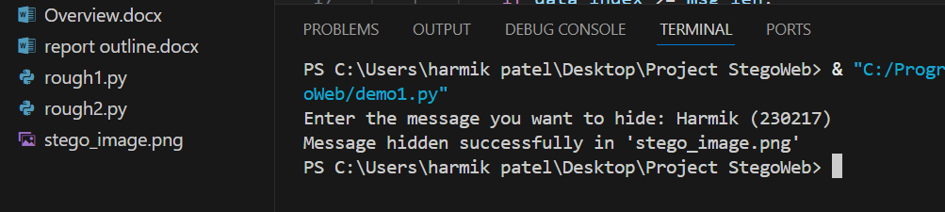

demo2.py [Extracting Code]
from PIL import Image

def binary_to_message(binary_data):
end_marker = '1111111111111110' # 16-bit end marker
end_index = binary_data.find(end_marker)
if end_index != -1:
binary_data = binary_data[:end_index]

message = ''
for i in range(0, len(binary_data), 8):
byte = binary_data[i:i+8]
if len(byte) == 8:
message += chr(int(byte, 2))
return message

def extract_message_lsb(image_path):
img = Image.open(image_path).convert('RGB')
pixels = img.load()
width, height = img.size

binary_data = ''
for y in range(height):
for x in range(width):
r, g, b = pixels[x, y]
binary_data += str(r & 1)
binary_data += str(g & 1)
binary_data += str(b & 1)

message = binary_to_message(binary_data)
print("Hidden message extracted:")
print(message)

image_path = input("Enter the path of the stego image (e.g., stego_image.png): ")
extract_message_lsb(image_path)

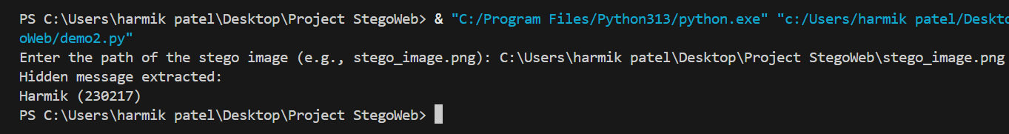
Output:

**I will link the other .py file of Prototype in e-mail

Working-
1. Embedding Algorithm (hide_message_lsb)
This algorithm hides a secret message inside an image using the Least Significant Bit (LSB) technique:
- The message is first converted into a binary string, and a 16-bit end marker (1111111111111110) is appended to signal the end of the message.
- The input image is opened and converted to RGB mode, allowing access to each pixel's red, green, and blue values.
- The algorithm iterates over the image pixels and modifies the LSB of each color channel (R, G, B) to store the binary message bits.
- Once all bits are embedded, the modified image is saved as a new file (stego_image.png).
- The change is imperceptible to the human eye, preserving the image's visual quality.

2. Extraction Algorithm (extract_message_lsb)
This algorithm retrieves the hidden message from a stego image:
- The image is opened and converted to RGB mode, then scanned pixel by pixel.
- The LSBs from each color channel (R, G, B) are extracted and collected into a binary string.
- The algorithm searches for the end marker to identify where the hidden message ends.
- The binary string (up to the marker) is then split into 8-bit chunks, each converted back into its character form to reconstruct the original message.
- The final message is printed to the user.

Challenges Faced During Development and How I Overcame Them
The development of the core steganography functionality presented several challenges, especially when moving from the basic conversion of a message to binary towards actual embedding and extraction of that message into/from an image. While converting a message to binary was relatively simple, the processes of embedding and extraction required deeper understanding of image processing concepts and the behaviour of libraries like Pillow and OpenCV.
Initially, I followed a hit-and-trial approach, testing various pieces of code and modifying them until they appeared to work. However, this quickly became inefficient as the project grew in complexity. To address this, I decided to design a structured flow, mapping out the main process and breaking it down into smaller, more manageable sub-processes. This helped in organizing the code better and troubleshooting more effectively.
As I encountered errors during development, I relied heavily on both ChatGPT and Google to understand the root causes of these issues. This research-oriented approach not only provided me with accurate solutions but also helped me understand the underlying problems, which improved my ability to write better and cleaner code.

Development of Prototypes
To solidify my understanding and test different approaches, I created three different prototypes:
- The first two were represented by demo1.py and demo2.py, which I shared previously.
- The third prototype was developed later using OpenCV to improve performance.
In the first two prototypes, I encountered a critical error during message extraction. After embedding a message and attempting to extract it, the output contained unexpected and strange symbols, such as:[ ÿ ].

This indicated that there were garbage values at the end of the extracted binary data. On investigation, I discovered that the issue was caused by an inconsistency in the end-marker logic. In the embedding algorithm, I had defined the end marker as an 8-bit value (11111110), while in the extraction logic, I mistakenly checked for a 16-bit marker (1111111111111110). This mismatch resulted in the algorithm failing to detect the end of the message correctly, thus reading extra binary values and converting them into non-standard characters.
Even after correcting this to a consistent 8-bit end marker in both embedding and extraction, I noticed that the output still contained a single garbage character at the end. After further debugging, I found that the root cause was the use of two completely different algorithms—one for embedding and another for extraction—which were not logically aligned. To fix this, I developed the second prototype from scratch using a consistent logic flow: the same structure used in embedding was applied in reverse during extraction. This resolved the issue entirely and produced clean output.

Performance Challenges
After stabilizing the logic, I encountered a performance bottleneck. The embedding process was fast and executed smoothly. However, the extraction process was slow, often taking between 15 to 25 seconds to retrieve the hidden message. In some cases, it even resulted in an infinite loop if the termination condition failed.
Initially, I assumed this was a hardware-related issue. However, considering the capabilities of my system (which is sufficient for heavier computational tasks), I ruled that out. I then suspected that the Pillow library might be the bottleneck due to its slower pixel-by-pixel operations.
To address this, I converted the entire embedding and extraction logic to use OpenCV, which is known for being faster and more optimized for image processing. This led to the development of the third prototype, using OpenCV-based logic throughout.
Surprisingly, even after moving to OpenCV, the extraction process remained slow. This indicated that the bottleneck wasn't in the library itself but possibly due to the inefficient looping logic or lack of early termination in the extraction function. I concluded that further optimization of the extraction algorithm is required at a logical level, rather than just relying on library changes.

Main Reason: Full Image Is Always Scanned
The code extracts every single pixel’s R, G, and B LSBs, regardless of how short the actual message is.
for y in range(height):
for x in range(width):
r, g, b = pixels[x, y]
binary_data += str(r & 1)
binary_data += str(g & 1)
binary_data += str(b & 1)
Let’s say:
- Image size = 1920 × 1080 (Full HD)
- Pixels = 2,073,600
- 3 bits per pixel = 6.22 million bits (777,600 bytes)
- Even if your actual message is only 100 characters, it still extracts all 6 million+ bits, which is completely unnecessary.

Why It’s Slow
1. Inefficient Binary String Construction
The most significant performance issue stems from how the binary string is built during extraction. Each bit is appended using += on a Python string within nested loops. Since strings in Python are immutable, each concatenation results in the creation of a new string object in memory. With millions of iterations, especially for high-resolution images, this results in a tremendous number of memory allocations and copies, severely impacting performance.
2. Absence of Early Termination Logic
Another major inefficiency is the absence of early exit from the pixel-reading loop. Even though the hidden message is terminated with a 16-bit end marker (1111111111111110), the program reads through every single pixel in the image before checking for this marker. This means that even if the message ends within the first few hundred pixels, the script still processes the entire image, wasting time and resources.

3. Slow Per-Pixel Access with PIL
The method used to read pixel data introduces additional delays. By calling pixels[x, y] for every single pixel, the script performs individual pixel reads using the PIL library, which is not optimized for high-speed access at this granularity. For large images, these per-pixel lookups add considerable overhead. The lack of bulk or vectorized access makes the loop significantly slower, contributing to the overall lag during message extraction.

Real Example
Image size: 1920 × 1080
- Pixel reads: 2,073,600
- LSB bits collected: 6,220,800
- Loop iterations: 2 million × 3 additions to a string = 6 million operations
So, for such logic , even a modern CPU takes time if the code is not optimized.

Other Alternatives
Technique | Speed | Security (Safety) | Compression-Safe | Notes
LSB (Least Significant Bit) | Very Fast | Low (easy to detect) | No | Simple but fragile
DCT-based (JPEG Stego) | Medium | High (harder to detect) | Yes | Works in frequency domain
Spread Spectrum | Slow | High (very robust) | Yes | Used in audio/video
Statistical Techniques | Slow | Very High | Yes | Advanced use cases
Neural Network-based | Very Slow | Very High | Yes | Best but complex

I have thoroughly studied and understood the working principles of the various steganographic techniques discussed. Based on the comparative analysis—particularly the balance between speed, security, and implementation complexity—I have decided to proceed with the DCT-based technique for the next phase of my project.
While neural network-based steganography offers the highest level of security and undetectability, it is also computationally intensive, resource-demanding, and requires significant model training and large datasets, which may not be practical at this stage. Similarly, spread spectrum techniques are highly reliable but are more suited for audio and video steganography, whereas my project currently focuses specifically on image and text-based data.
Considering these factors, I believe the DCT-based method is the most appropriate and effective choice for my current objectives.

However, I would still appreciate any additional suggestions or recommendations you may have to further improve the implementation or overall robustness of the system and in design .

Plan for the Upcoming Week
- I am currently working on implementing a DCT-based steganography technique, as previously mentioned. Given the UI design, which allows users to input either plain text or a file, I am considering using:
  - Simple LSB for hiding plain text messages, and
  - DCT-based steganography for file embedding.
However, I'm still uncertain whether it would be better to apply the DCT method for both text and file inputs to maintain consistency and higher security. I would appreciate your suggestions on which approach would be more appropriate.
- I will finalize the design for the second page of the interface.
- I plan to complete the color mode detection logic by integrating the Pillow library. Additionally, I will implement an encryption toggle feature to enhance security and make the embedded data more resistant to detection, using the Python Cryptography library.
If there are any design changes you'd recommend or if you feel that any part of the chosen algorithmic approach may be redundant or irrelevant, please feel free to suggest improvements or alternatives. Your feedback would be valuable for refining both functionality and usability.

